INTRODUCTION

Dear Students,
Welcome to YSpacE! Are you a driven student with an idea to start a new and exciting venture in the space industry? If so, then the SEDS-Canada Young Space Entrepreneurs (YSpacE) competition is your first step in turning your ideas to reality. The only business plan contest in Canada geared towards students interested in the space sector, YSpacE is your opportunity to get the first taste in entrepreneurship on a topic that you are passionate about.

In this brief rule book, you will find information about rules and regulations of the competition, deadlines for submissions, and guidelines on how to complete these submissions. You are encouraged to contact the organizers, listed under ‘Important Contacts’, for further details.

We look forward to your participation in this challenge!
— The entire SEDS-Canada team

SEDS-Canada (Students for the Exploration and Development of Space) is a student-run non-profit, federally incorporated since October 2014. We are a member-based organization with hundreds of members all across Canada, and we partner with many established university student groups.
We are dedicated to promoting the development of the Canadian space sector and supporting our fellow students who wish to pursue careers in this industry. To achieve this mandate, we offer students opportunities for professional development. Our strategy includes national competitions such as CAN-RGX and CAN-SBX, an annual conference, and eventually, competitive grants.

IMPORTANT CONTACTS
NOTE: For submission of project milestones email yspace@seds.ca
Agasthya Rana | YSpacE Project Manager |
agasthya.rana@seds.ca | (289) 489-8333
Agasthya is pursuing a Bachelor's in Engineering Physics at McMaster University. His love for space exploration and education led him to SEDS and finally YSpacE! He looks forward to helping student participants gain valuable entrepreneurship experiences and provide the best support for their success in the YSpacE competition.

Ahmad Khan | YSpacE Assistant Project Manager |
ahmad.khan@seds.ca
Ahmad is currently a first year student at Wilfrid Laurier University and is pursuing a Bachelor of Science in Mathematics. He has a strong interest in solving problems by looking at them from a different perspective which has led him to pursue a career as a mathematician. He loves bringing ideas together and looks forward to helping teams bring their ideas to life!

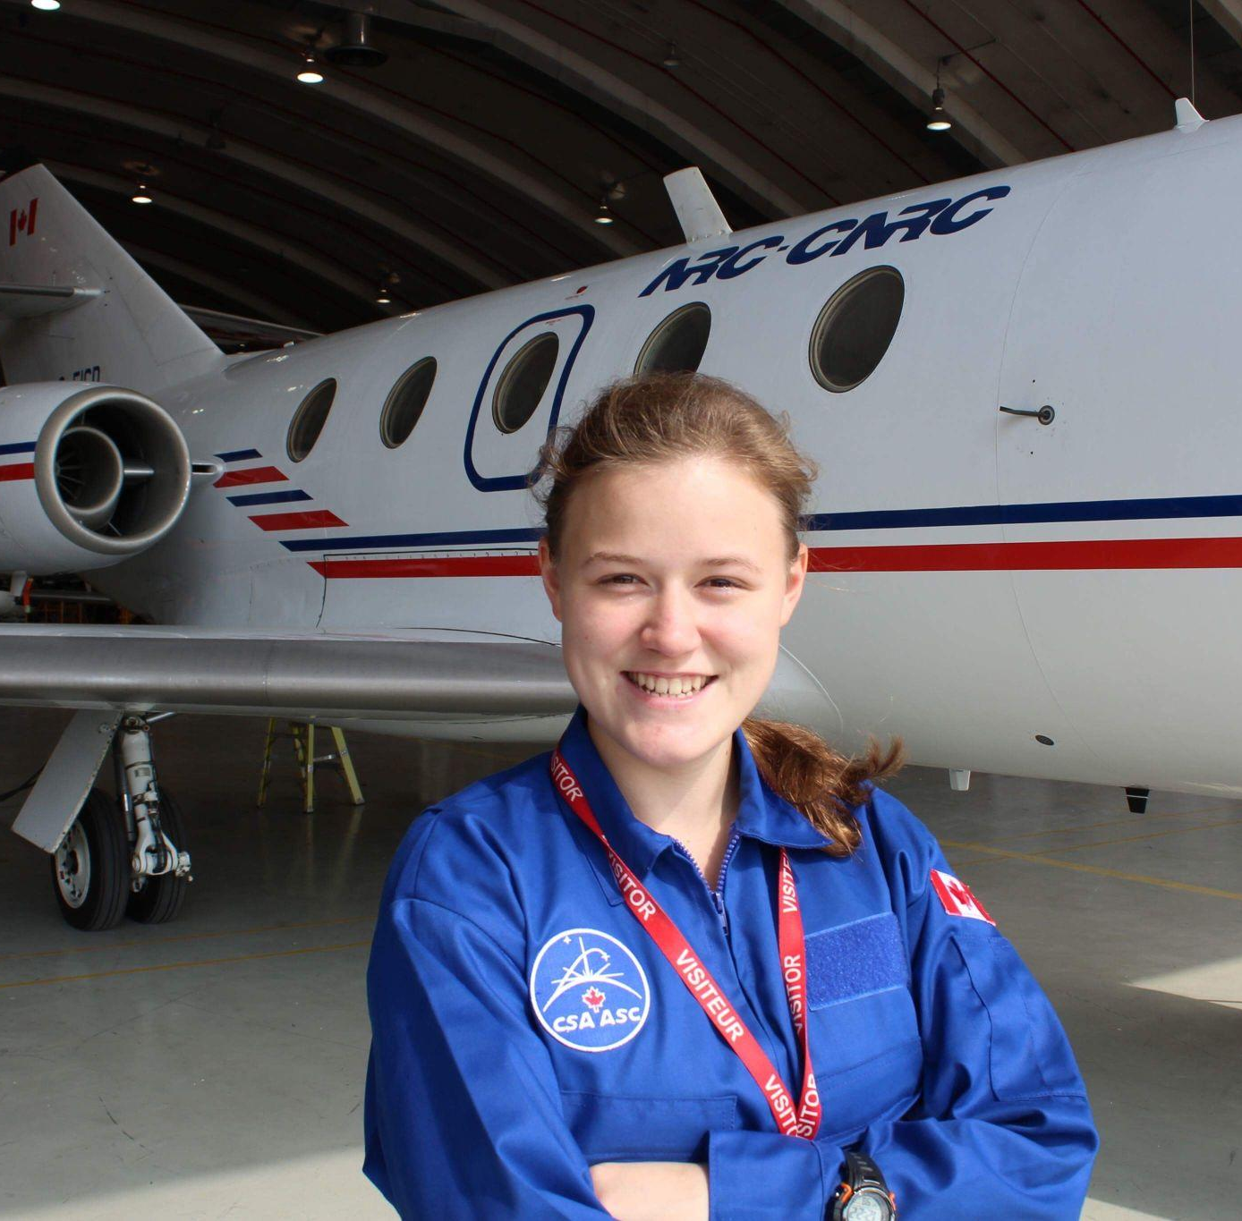
Alina Kunitskaya | SEDS-Canada Projects Chair |
alina.kunitskaya@seds.ca | (403) 400-1559
Alina Kunitskaya holds a BSc in Chemical Engineering from the University of Calgary and is currently a PhD candidate in Biomedical Engineering at the University of British Columbia. Her passion for solving space exploration challenges led to her involvement in developing a process to recycle astronauts’ fecal waste into 3D-printable bioplastics, developing and flying a scientific payload in microgravity as part of SEDS-Canada CAN-RGX project, developing an oxygen production process on Mars, and completing a simulated sub-orbital spaceflight to help scientists examine the physiological and psychological impacts of g-forces associated with spaceflight. She is excited to continue working with SEDS-Canada to provide students with hands-on opportunities in the Canadian space sector.

COMPETITION OVERVIEW

Project Scope
The Young Space Entrepreneurs (YSpacE) Competition is Canada’s only entrepreneurial competition specifically designed for new and innovative business ideas for the space industry. Registration for YSpacE 2022-23 will open on September 8, 2022. After students are selected, the competition will run until the end of January 2023, where the top teams will get to pitch their business idea at our annual Canadian Space conference.

YSpacE will take you through the building of a solid business plan. Although we encourage applicants to come to YSpacE with some idea for a product or service, we’re opening our applications for students who may not yet have an idea but will commit to finding one.

During the competition, students will receive advice from experts in the space sector through a series of webinars to coach them on preparing their business proposals and project pitches. These webinars are only for individuals who register for our competition. SEDS-Canada will also match you with a mentor, and our graphics team will assist you in designing the perfect logo for your venture.

Most start-up competitions culminate in an investment deal for the winning teams. While our competition is primarily designed to provide a chance for students to learn what it takes to create a business plan, in 2016 the winning team was offered an opportunity to join an accelerator program to take their ideas to the next level, and a participating team from 2019 was recently awarded a contract from Canadian Space Agency for a space debris removal feasibility study. If a judge or mentor is interested in investing in your idea or helping you post-YSpacE, it is entirely up to you and the judge to work out the terms of the offer or agreement.

At least one member of your team will need to be a member of SEDS-Canada. We strongly encourage your team to be a mix of technical and business students as complementary skills will allow you to learn more and maximize the chance of succeeding in this competition. There may be the opportunity to have SEDS-Canada match students to your team if their expertise and interests align with your needs and your vision; you can opt-out or opt-in to this while applying.

Eligibility
YSpacE focuses on new, independent ventures that advance the space sector in Canada. Technologies from university research labs are encouraged assuming no previous commercialization of the technologies.

Both individuals and teams can participate! In either case, you must have an idea for a relevant product or service or commit to trying to find one over the course of the competition.

For individuals:
- Students must be from a Canadian post-secondary institution. Proof of enrollment must be submitted with the application. This includes items such as an unofficial transcript, a letter from your university or college registrar, a copy of your student ID with an expiration date, or a screenshot of your term schedule showing your name.

For teams:
- At least 2/3^{rds} of the team must be comprised of students enrolled in a Canadian post-secondary institution. Proof of enrollment must be submitted with the application for these students. This includes items such as an unofficial transcript, a letter from your university or college registrar, a copy of your student ID with an expiration date, or a screenshot of your term schedule showing your name. The remaining team members may be students studying at a Canadian high school; proof of this must also be provided.

Individuals (or teams) interested in finding team members (or more members) can be matched with other individual participants based on their expertise and interests. You can opt into this on our application form. To be eligible to advance to the pitch competition, an individual or one member of a team must become a member of SEDS-Canada. Additionally, an individual or at least one person from each of the finalist teams must register for the Canadian Space conference 2023, our annual conference which this year is fully online, to present to a panel of judges.

Competition Timeline
All submissions should be made to yspace@seds.ca (unless otherwise specified) Check the YSpacE web page regularly for any updates to this timeline.
- Thursday September 8, 2022: Announcement of opportunity
- Friday September 30, 2022, 11:59 PM (EDT): Due date to submit your Application using this Google Form.
- Friday, October 7, 2022: Confirmation of participation. Individuals looking for team members will be matched with other participants/teams.
- 2^{nd /3rd}Week of October: Team introductions and virtual meet-up; introduction to Business Plan Guidelines. Bi-weekly SEDS-Canada webinars covering the content of the guidelines thereafter.
- Sunday, November 27, 2022, 11:59 PM (EST): Business plan updates – Deadline 1
- December 1, 2022: Webinar 1: Discussion with Iain Christie, the CEO of Neptec Design Group
- Saturday, December 17, 2022 at 11:59 PM (EST): Business plan updates – Deadline 2
- Late December, 2022: Webinar 2 (topic TBD)
- Monday, January 2, 2023 at 11:59 PM (EST): Business plan updates – Deadline 3
- Early January, 2023: Webinar (topic TBD)
- Saturday, January 19, 2023, 11:59 PM (EST): Business plan updates – Deadline 4; Business plan complete!
- Thursday, January 26, 2023, 11:59 PM (EST): Pitch slides are due
- Late January: Webinar (TOPIC: How to give an effective pitch & communicate your ideas) TBC
- January 28 at 1:30 – 2:30 pm EST: YSpacE Finals @ Canadian Space Conference 2023 (HYBRID)

BUSINESS PLAN
You need a business plan to get ideas out of your head and onto paper. With an effective business plan, you’ll be able to convince possible shareholders that your ideas are legit, and you have an action plan for the funding and expertise they will provide. The same is true if you’re applying to a governmental (or other) grant.
You’ll be given a Business Plan Guidelines document that also serves as a template for your business plan. The sections that we will guide you through creating are:
- Executive summary
- The Team
- Product/service description
- Motivation
- Value proposition
  - How is this product/service valuable?
- Intellectual property [if applicable]
- Market analysis
  - Including size of market and how your product/service fits into the market
- Competitor analysis
  - How are you different from your competitors?
- Target customers
- Management structure
  - Key activities,
  - Key partnerships,
  - Key resources (what will you need to take this product to market)
- Financial highlights
  - Including revenue model and projections,
  - Amount of investments needed,
  - Return on investment (with timeline)
- Execution plan
- Timeline including major milestones for the next year
- Risk Assessment
Different business ideas will be unique in their own ways and some sections might not be relevant to your idea, but these are the basic categories we cover.
The business plan will be filled out, submitted, and reviewed in sections. All submissions must be sent to yspace@seds.ca or posted in the relevant Discord channel. The rolling deadlines are as follows (the specific content due at each deadline is made clear in the Guidelines):
- Guideline deadline 1: November 20, 2022 at 11:59 PM EST
- Guideline deadline 2: December 10, 2022 at 11:59 PM EST
- Guideline deadline 3: December 20, 2022 at 11:59 PM EST
- Guideline deadline 4: January 14, 2023 at 11:59 PM EST
Final submissions will be reviewed, and up to 5 selected finalists will pitch at the Canadian Space Conference 2023.

PITCH PRESENTATION
Three teams will participate in the YSpacE finals at the Canadian Space conference. There, you will have to pitch your product/service to a panel of judges with expertise in business, entrepreneurship, and (aero)space. The Canadian Space Conference 2023 will be hosted in a hybrid format. If attending in person, teams will be responsible for their own travel costs to Montreal. Teams will present for a maximum of 10 minutes, followed by questions from the judges. Multimedia presentations and working or non-working demonstration videos or simulations of your product or service are encouraged.

Pitch Presentation Structure
The presentation should cover main points from your Business Plan and at the same time should engage and inspire the audience – you’re really trying to tell a story about the vision of your business.

The presentation should follow this slide structure explicitly. Any deviations from this slide structure must be approved by the YSpacE planning team.
- Title slide with logo & key statement
- Slide 1: What is the problem (i.e. the problem that your product/service is solving)?
- Slide 2: How does your product/service solve the problem (value proposition)?
- Slide 3: What is your product/service (in more detail)
- Slide 4: Market (size of your main market, which market are you selling to first)
NOTE: If your first market is not space-related, you should sell the vision here – detail the space-related market, and specify the entry-market on another slide right after this. If this is applicable to your team, make sure to go through your presentation with the YSpacE planning team first, so that we can help craft your message.
- Slide 5: Value Chain i.e. who are your partners/what key activities are you focusing on versus outsourcing
- Slide 6: Customers (who are you selling to)
- Slide 7: Competitors (who are your competitors) & competitive advantage (why are you better than them)
- Slide 8: Financial highlights (when will you need/get money) & timeline (what/when are your key activities). Mark your first revenue on the timeline.
- Slide 9: Team (who is on the team and why are you the team to excel in this space?)
- End slide (contact information)

If at any point you have a really good anecdote from one of your external meetings, include it!
NOTE: SEDS-Canada has no part in judging the winners. Feel free to bounce slides or ideas for slides off of the YSpacE planning team as you design them, or even the full presentation for comments. We’re here to help!
We have some pretty generic Google Slides templates that you can look at for inspiration (but please, don’t use these *exact* templates for your pitch, as the slides should represent your vision – and there would also be a chance two teams have the same presentation):
- Simple Modern
- Professional Modern
- Funky Modern
- Science Modern

To use slides from these templates, or to copy over pieces, select File>Make a Copy, and it will made an editable version in your own drive. Note: if “Make a Copy” is greyed out, you just need to sign in to your Google Drive account.

Each of them have some good flowchart, timeline, chart, and other simple visual graphics at the end of the template that can be coped into your pitch for good visual storytelling! We recommend you use these graphics to spice up your presentation. Here’s an example of those graphics:

Pitch Presentation Judging
The judges will consider and give a rating on a scale from 0 to 3 for each slide item (0 being no details provided, 3 being exceptional detail provided) under the following four categories:
- motivation,
- relevance,
- clarity
- feasibility
Note that for some slides, these categories may not apply, and so they won’t be scored on. The total score is based on both the pitch presentation itself, and the business plan.
The way you answer judges questions will factor into your score as it relates to clarity.

AWARDS
The top team will receive prizes (in the past, we’ve awarded cash prizes ranging from $200 – $600). Stay tuned for the announcement of this year’s awards!

Cash prizes will be delivered via e-transfer. Judges’ decisions are final.
All participating YSpacE students will receive certificates of project completion (as well as certificates relating to each prize, if appropriate).

COPYRIGHT
If a team uses copyrighted material, images, or videos from a third party in their proposal or/ and presentation, they must provide permission and authorization from the owners to use this material in advance. Any data or information discussed or divulged throughout the competition should be considered information that will enter the public domain. SEDS-Canada may make photographs, video recordings and/or audio recordings of the presentations and reserves the right to use these materials for advertisement.

